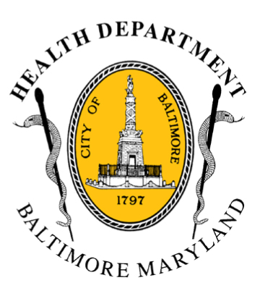
BCHD PRESS RELEASE
Baltimore City Health Department
1001 E. Fayette Street • Baltimore, Maryland 21202
Stephanie Rawlings-Blake, Mayor
Leana Wen, M.D., Commissioner of Health

FOR IMMEDIATE RELEASE
Media Contacts:

Michael Schwartzberg, PIO
O: (443) 984-2623 C: (443) 462-7939 E: michael.schwartzberg@baltimorecity.gov

Jennifer Fuson, Communications Specialist
O: (410) 545-0823 E: Jen.Fuson@baltimorecity.gov

Fentanyl-Related Overdose Deaths Up 178% In Baltimore
In First Quarter Of 2015

Baltimore City Health Department Educating
Drug Users About Dangers Of Fentanyl

BALTIMORE, MD (July 6, 2015) - Baltimore City health officials are issuing a warning and launching a public education effort about life-threatening fentanyl-laced heroin on the streets in Baltimore.

In the first quarter of 2015 (January – March), there have been 39 overdose deaths in Baltimore associated with fentanyl, an increase of 178 percent from the same time in 2014 (14 deaths). There were 303 overdose deaths in Baltimore in 2014.

“Fentanyl-laced heroin is killing individuals in our city,” said Dr. Leana Wen, Baltimore City Health Commissioner. “Nearly every day in Baltimore, one person dies from drug overdose. This is a public health emergency. It is our obligation to educate and save lives.”

Earlier this year, as part of the Mayor’s Heroin Prevention and Treatment Task Force, BCHD launched the citywide overdose effort.

Starting today, BCHD is expanding the effort specifically to make active drug users aware of this issue and sharing “Here’s How You Can Stay Alive” fliers with heroin users via its Needle Exchange Program mobile unit, street outreach teams, word of mouth in the user community and through other distribution methods.

Tips include:

- Never use alone.
- Carry a naloxone kit. Naloxone is a safe and effective antidote to heroin and fentanyl, and is a critical tool to preventing opioid overdoses.
- Notice changes in color and texture and go slow if it is different than normal.

- more -

2-2-2

Health officials caution that users may be unwittingly buying heroin laced with fentanyl or buying what they think is heroin, but may be fentanyl without any heroin.

Fentanyl is a potent opioid used for medical treatment that is 50 to 100 times more potent than morphine. According to the National Institute on Drug Abuse, mixing fentanyl with street-sold heroin amplifies its potency and potential dangers. Effects include confusion, loss of consciousness, stopping breathing, and death.

“Fentanyl is such a powerful drug that it is often too late by the time emergency assistance arrives,” said Dr. Wen. “That’s why it’s so important for users, family and friends, and all of us as concerned citizens to be educated and to save lives.”

Free overdose prevention training, including naloxone kits, are available through the Baltimore City Health Department, by calling 410-396-3731 or http://health.baltimorecity.gov/

According to the Drug Enforcement Administration, there is a recent surge in fentanyl across the United States:

- The New Hampshire State Laboratory recently reported four fentanyl overdose deaths within a 2-month period.
- New Jersey saw a spike in fentanyl deaths in 2014, reporting as many as 80 in the first 6 months of the fiscal year.
- Rhode Island and Pennsylvania have also seen large increases since 2013. In a 15-month period, about 200 deaths were reported in Pennsylvania related to fentanyl.
- In June 2014, the DEA in New York dismantled a heroin and fentanyl network and arrested the two heads of the organization. These individuals were linked to at least three overdose deaths from the heroin and fentanyl they sold.

###

